**HTML**

**UNIT 1**

**HTML Tags, HTML Attributes, HTML Editors, HTML Document Structure HTML Headings, HTML Paragraphs, HTML Styles**

**LEVEL 2**

1. Create a web page to display the algebraic expression x2+y4+z3.
2. Create a web page to display 4 paragraphs with each paragraph different colour and font style.
3. Create a webpage to display the background image and information with paragraph justified.
4. Display the output as follows

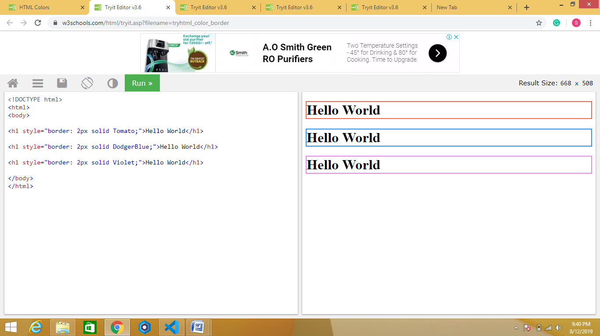

1. Create a web page to display background image using style attribute